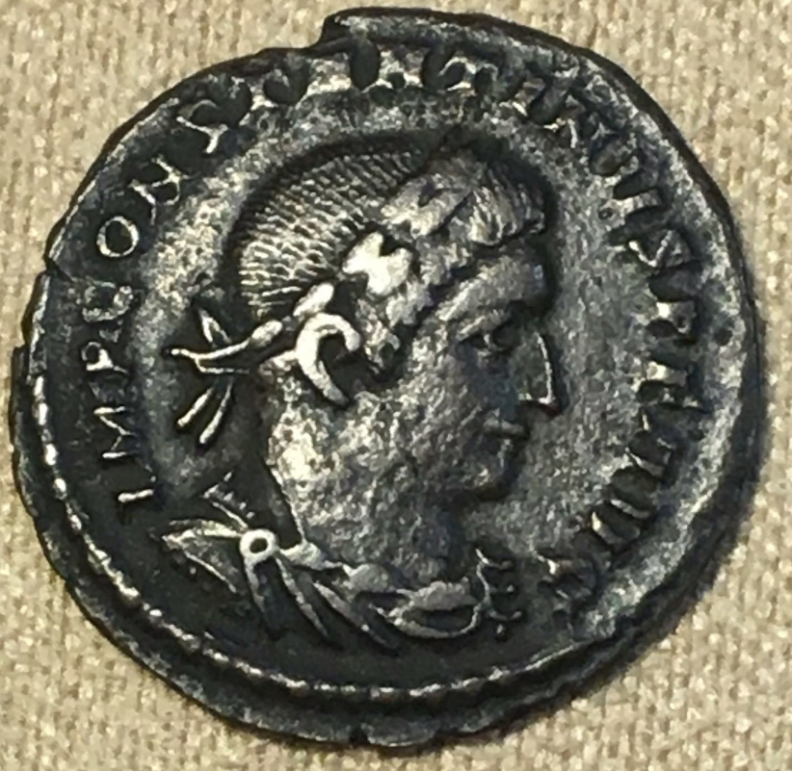 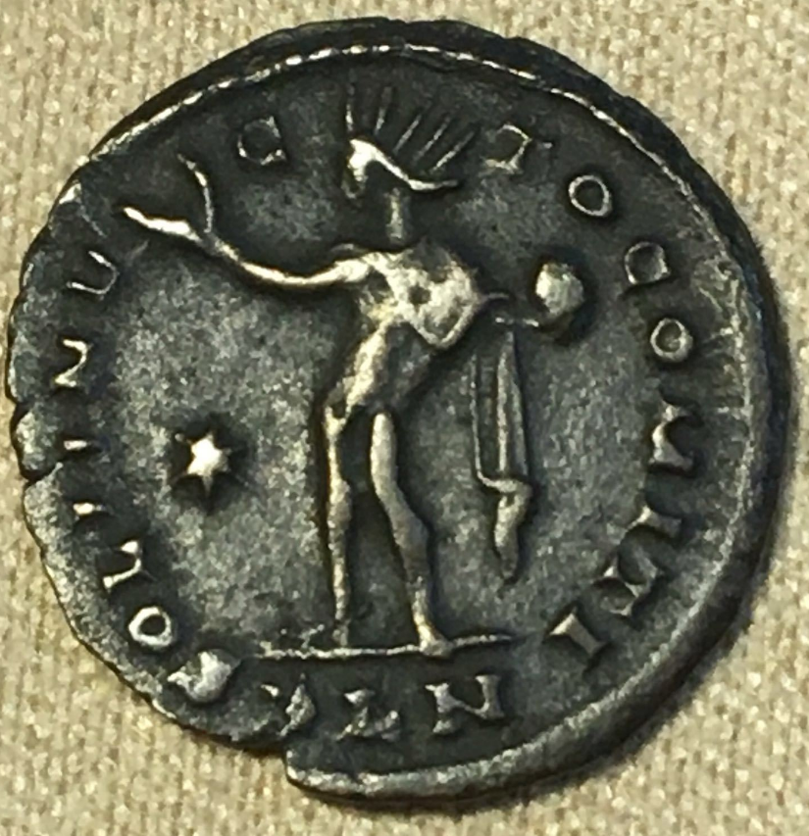

ROMAN EMPIRE

LONDON, LONDINIUM  "PLN"

OFFICINA P (PRIMA OR 1)

COPPER 1 FOLLIE

EMPEROR CONSTANTINE

ND-306-337 AD

EF/EF+